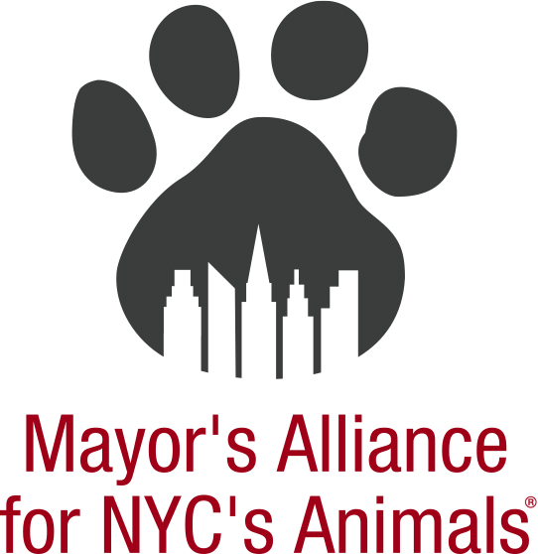
Steve Gruber, Director of Communications
Mayor’s Alliance for NYC’s Animals
Hearing before the New York City Council
Regarding a proposal to Repeal and Re-enact Chapter 5 ("Pet Shops") of the Title 24 of the Rules of the City of New York regarding rules prohibiting sale of dogs, cats and rabbits by pet shops
Hearing Scheduled for Friday, December 5, 2025

This comment concerns the proposal by the New York City Department of Health and Mental Hygiene to repeal and re-enact Chapter 5 of the Title 24 of the Rules of the City of New York to align with amendments to State and local laws that prohibit pet shops from selling or offering for sale dogs, cats or rabbits. The proposed rule also adds provisions governing the prohibition against the sale or offering for sale of guinea pigs pursuant to local law.

The Mayor’s Alliance for NYC’s Animals has, since 2003, worked collaboratively with the city’s animal welfare community to reduce the number of pets entering New York City’s animal control shelters. One of the most effective means of reducing the burden on the City’s shelters is by curbing the pipeline of animals entering the shelter by prohibiting pet stores from selling animals that are most likely to end up at the shelters, including dogs, cats, rabbits, and guinea pigs.

We have supported previous legislation to ban the sale of dogs, cats, rabbits, and guinea pigs in New York City. Now, we support this most recent proposal to repeal and re-enact Chapter 5 of the Title 24 of the Rules of the City of New York to align with amendments to State and local laws that prohibit pet shops from selling or offering for sale dogs, cats, or rabbits and the proposal’s provisions governing the prohibition against the sale or offering for sale of guinea pigs.

We thank the Department of Health and Mental Hygiene’s for its efforts to coordinate the rules of State and local law to protect dogs, cats, rabbits, and now, guinea pigs, and thereby help reduce the flow of homeless animals into our overburdened Animal Care Centers of NYC.

Thank you.

