Skip Blumberg
Friends of City Hall Park
info@CityHallParkNYC.org

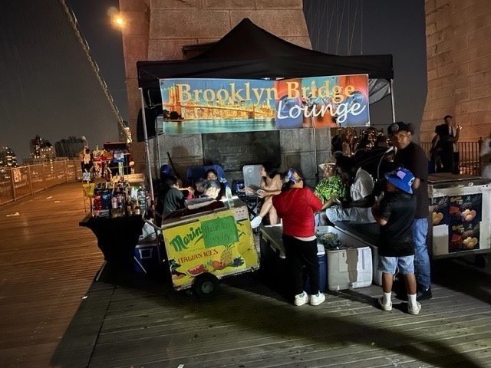

with lawn chairs, snacks & full bar!

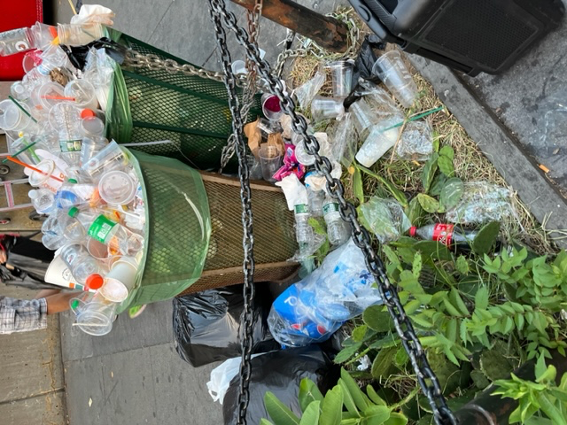
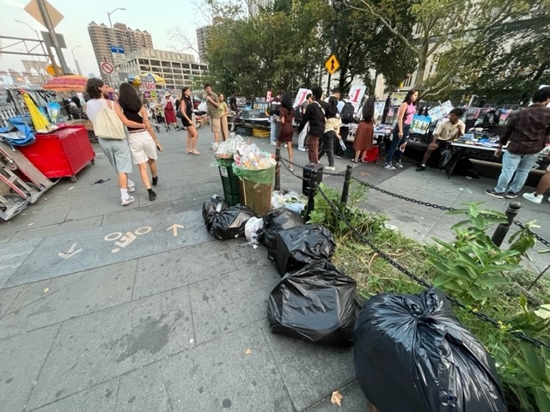
Northeast Prickly Pear Cactus Bed buried by vendors’ & customers’ trash!

