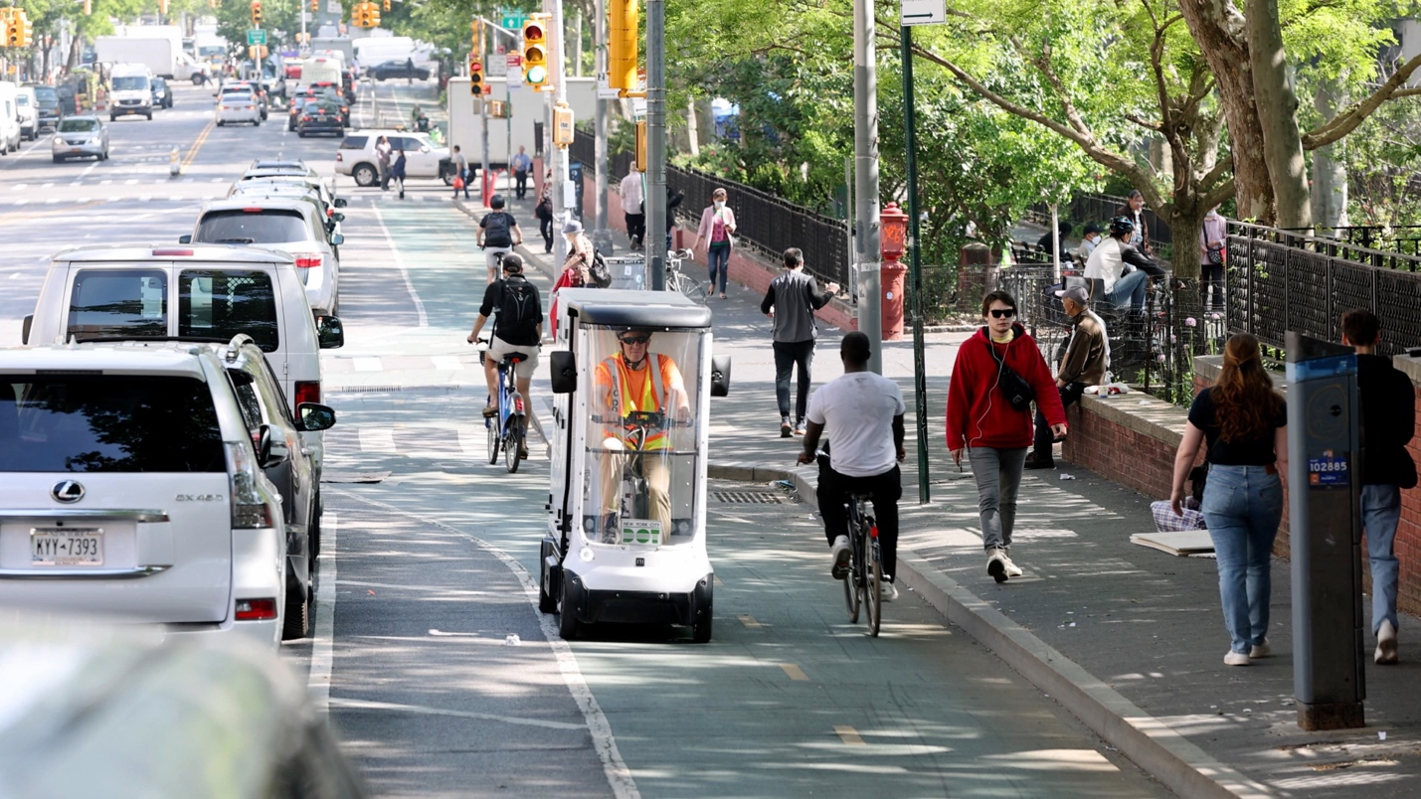Courtesy of the Transportation Department

