DEP proposal to amend its rules governing house/site connections to the sewer system

https://rules.cityofnewyork.us/wp-content/uploads/2021/12/Ch-31-Amendments-for-City-Record.pdf

Proposed rule
The proposed rule in question is a follow up to the 2012 house/site stormwater rule, which had the goal of reducing the damage during and after rainstorms. The document describes how overflows and backups can take place when “excessive water from impervious surfaces enters too quickly into the sewer system”. The 2012 rule “set forth a new performance standard, which applied to development in combined sewer areas of the City, allowing the City to more effectively manage stormwater runoff by prescribing standards for the permitting, construction and inspection of sewer connections to the City’s combined sewer system.”

Following this rule, a permit was issued by the New York State Department of Environmental Conservation requiring “the City to implement measures to reduce pollution in stormwater runoff from developments in the MS4 areas of the City (Chapter 19.1 of Title of the RCNY, construction/post-construction stormwater management requirements), with the goal of protecting and improving water quality in the City’s waterbodies.”

A map of the MS4 areas (accessed on the NYC DEP’s website) is shown below:
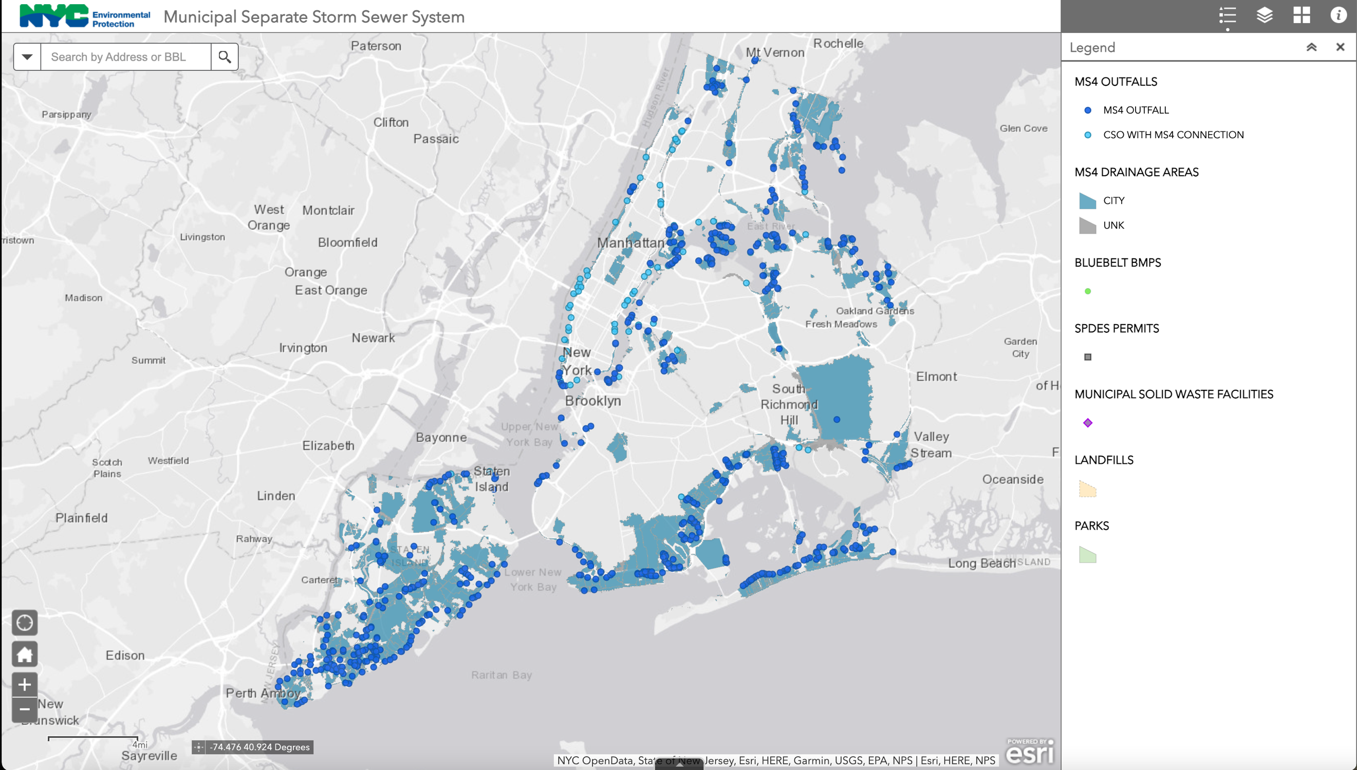
(Retrieved from: https://nycdep.maps.arcgis.com/apps/webappviewer/index.html?id=81c926d182454388869ff135ef603c60)

The new rule seeks to implement a more unified approach to stormwater regulation citywide. The proposed rule will also encourage “re-development projects greater than or equal to 20,000 square feet (sf) to use green infrastructure to meet the requirements of both chapters, where feasible. These amendments will allow for reduction in combined sewer overflows and flooding, increase in green space, greater consistency across stormwater programs, flexibility in design options and improvements in water quality.”

From the list of what the proposed amendments would entail I have highlighted a few keys points. The proposed amendments would require applications to include site plans, stormwater volume requirements, “actual stormwater release rate from the site, and the maximum stormwater release rate”. The proposed amendment around inspections also “clarifies that the Department of Buildings will inspect the building drain(s) and the Department will inspect the building sewer(s).” In addition, the proposed amendments also address potentially changing hydraulics for “areas covered by rezoning”. The proposal highlights that there is an opportunity during rezoning and redevelopment to retrofit existing structures in ways that could “benefit the drainage system and water quality”.

Response

I am a resident of New York City and I am a first year graduate student in the city & regional planning program at Pratt Institute. I have seen the effects of excessive amounts of rain during and after storms in this city, most recently-and extremely-in September of this year. We saw more rain than our sewers could handle. We were ill-prepared not only for the downpour during the storm, but also ill-prepared in how to prepare in advance of the storm and how to manage the after-effects. Our city has also seen, or continues to see, an incredible amount of building development.

The focus on the issue of impervious surfaces stands out as vital, as we live in a city that is largely paved and built over, destroying the naturally occurring ground surfaces that mitigated water flow. Working to replace impervious surfaces with greener infrastructure is important when speaking about stormwater programs—they are linked.

One area of concern I have, that may be addressed by another amendment, is that the storm surge and runoff issues were not only seen in the MS4 areas highlighted by the map, and therefore limiting regulations to these areas does not put in place systemic guidance and oversight on smaller projects (under 20,000 square feet) or projects outside of the highlighted areas. Unfortunately, what we saw in September of this year, and will likely see again, is that runoff and flooding existed in areas all over the city—sewers were backed up in basements of buildings well out of the marked areas, in areas of higher elevation, in and around subways, and in and around homes whose structures were built over what had historically been a body of water or marsh area.

The sewer system and its peripheral connections need more attention, more funding for retrofitting, and oversight. It is infrastructure that our city cannot afford to function without. We cannot build or develop in the city without appropriate capacity of the sewer systems, and these issues and the larger concern about water quality affect public health. This proposed rule seems to offer more clarity about procedures and about the departments in charge of oversight and compliance. It also is beneficial in that it looks to integrate green infrastructure. One last concern to keep in mind is that the runoff and storm surges we have experienced are not likely to be the worst we will see in the years to come. It is important for regulations, procedures, and guidance to be forward-thinking, clear and accessible to the public, and for government officials to have capacity to provide consistent, ongoing, and comprehensive oversight.

